# Operating Systems 1

## Tanmay Garg CS20BTECH11063

Programming Assignment 2

**Program Design:**

* First the program opens the input.txt file which has the required input for number of threads, size of array, and array elements
* It then scans from the file and places the array elements in the global array
* An array of pthreads is created and an array of struct arguements_multithread is also created which will have the parameters that need to be passed in the thread for merge_sort function
* The entire array is divided into N sub arrays where N is the number of threads, and each subarray has a size of $\left\lfloor \frac{size of array}{number of threads}\right\rfloor$
* Each thread calls the merge_sort function which is recursive in nature
* Only the starting index and ending index are provided as parameters, and all changes are done in the global array
* Each sub array is merge_sorted in its respective threads
* After all the threads are joined then the merge function is called to merge all the sub arrays from the main thread
* The function is merge sort which works on the principle of divide and conquer
  + The entire array is divided into 2 almost equal parts and the function is called recursively on these 2 arrays
  + After reaching the base condition of recursion, the 2 subarrays are merged such that smaller elements are put first and then larger numbers
  + This cascades all the way to the top in the original array
* The time has been calculated between the following 2 points
  + Just after the array is created or initialized
  + Just after merging all the subarrays
* For the Comparison Part
  + The program needs to be run multiple times and number of array elements and number of threads should be changed in the source code at appropriate lines (Mentioned in the comments in the source code)

**Sequential v/s Parallel:**

* The first comparison is when the number of threads is increasing, and the size of array is fixed
  + Chart, scatter chart

    Description automatically generatedThe program has been run 100 times for each number of thread and then the averages for all have been plotted. Size of array is 50000
* The second comparison is when the size of array is increasing, and the number of threads is constant
  + The program has been run 100 times for each size and then the averages for all have been plotted. Number of threads is 16

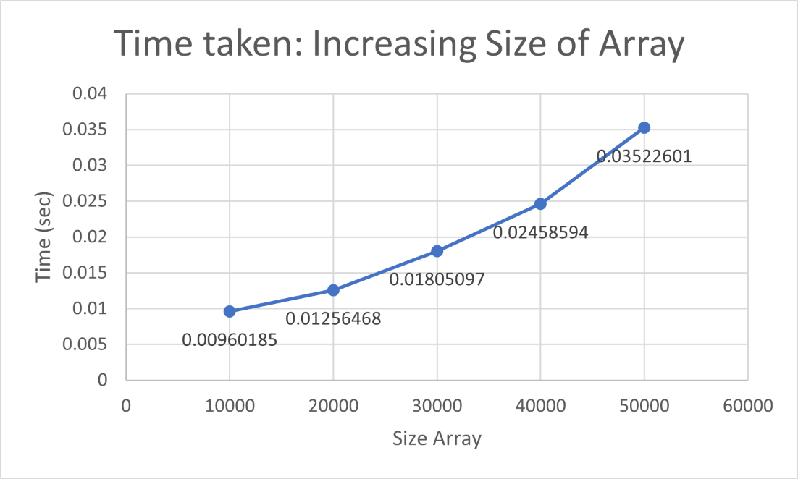

Note:

* The following comparison has been done only for 100 iterations for each type and the average has been taken for the values
* The values may differ based on the on the user’s system and specifications and compiler optimizations and will also depend if the program is run on different Operating Systems, its architectures and whether it is a Virtual Machine or not
* To run the first part of the assignment, which is taking input from file and giving output to file, comment the second main function and uncomment the first main function
* To run the report part of the assignment, comment the first main function and uncomment the second main function